Holy Family School 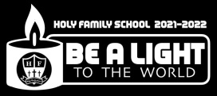

Where Faith and Learning Come Together

To: Parents of Holy Family School Students

From: Sister Christina Marie, CSSF
Date: March 8, 2022
Re: Happenings at Holy Family School

Dear Parents,
We cannot pray the Peace Prayer or live it fully until we begin to see ourselves as disciples called to live the life Jesus Himself lived. Yes, we are challenged to think of ourselves as brothers and sisters of Jesus called to the same heights of self-giving love as Jesus. Bringing love for hatred, pardon for injury, hope for despair, light for darkness, and joy for sadness was what Jesus did on earth. This pattern of resisting evil with good followed from Jesus’ relationship with the Father. Easy for Him to do we might object because He was the Son of God. But Jesus revealed that we also are sons and daughters of God, and He promised that we can do even greater than He because of our relationship to the Father and the gifts of the Holy Spirit. Soren Kierkegaard wrote: “Christ comes to the world as the example, constantly enjoining imitate me. We humans prefer to adore him instead.”
We are called not just to believe in Jesus in the sense that we trust that He saved us, and given us Scripture, the sacraments, and the Church to help us get to heaven. We are also called to believe as Jesus believed—to respond to life as Jesus responded.
Do I realize that I am called to believe and to live as Jesus did? To respond to others as Jesus responded to them. During these days of Lent may we reflect on how we live like Jesus and imitate Him – to pray especially for those suffering in the Ukraine and those in refugee camps fleeing from the Russian invasion.
Blessings,
Sr. Christina Marie Luczynski, CSSF

Out of Uniform Day
Monday, March 14, 2022 will be an out-of-uniform day. Students are encouraged to dress in the Ukrainian country colors of yellow and aqua blue. Donation of a dollar as usual or more if you wish. I thank Mrs. Casamano and her son for making the banner for us. Please keep my community of Sisters in your prayers also. We have approximately 18 Felician Sisters from our Polish Community in the Ukraine working in various Parishes.

Gertrude Hawk Sale
Our Gertrude Hawk Easter Candy Sale will be extended through this week. Flyers have gone home with every child. This is a very popular sale and a great fundraiser for the Home and School Association who sponsor such wonderful events for our children and faculty. Thank you for your support.

Please Note
There will be No School on Tuesday, April 5, 2022 for correcting of NYS ELA tests and again on Tuesday, May 10, 2022 for NYS Math correcting of tests.

Thank You
Thank you to Steve and Ken our maintenance crew for installing our water filling station in the cafeteria. The students have been enjoying and using it.

Registration
Some families have had some trouble with re-registration so here are the steps. If you continue to have trouble, please contact Mrs. Skinner, my secretary to walk you through the problem.

Reenrollment Steps:
- Visit the factsmgt.com website
- Go to Parent Log in drop down and select FACTS Family Portal
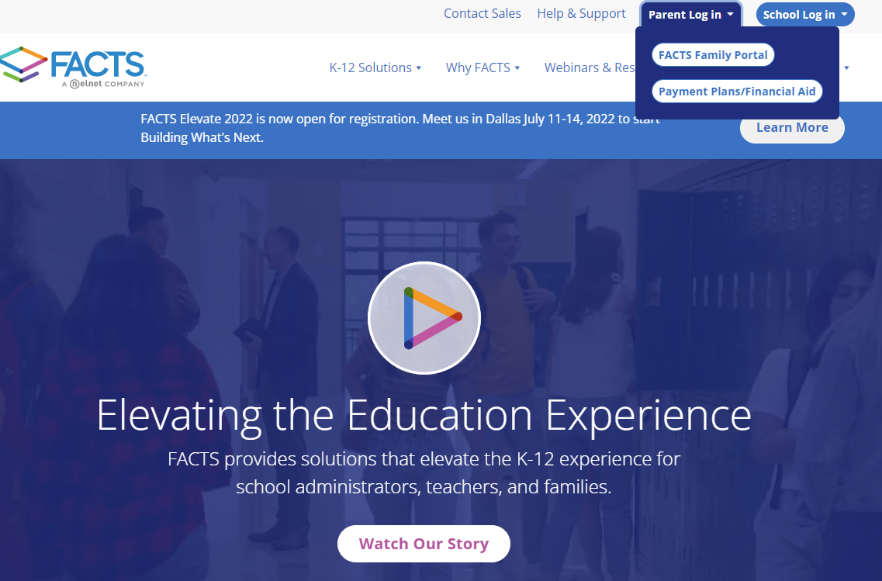
- Create New Family Portal Account

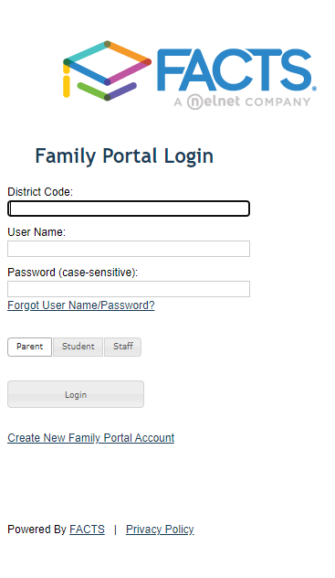
- You will be asked to enter your email and an email verification will be sent. Please allow up to 5 minutes to receive the verification email.
- Once the verification email has been received, click the link to complete the Login Set up
- District Code if not provided is: HF-NY
- Once logged in, select reenrollment on the bottom left of the screen.
- Complete the required fields
- Submit after final review

Faculty/Staff for 2022-2023
I have postings for the following grades for those teachers who are retiring and/or moving on:
Grades 6, 5, 3, and 1 as well as PreK, music, library, and Spanish. I have had inquiries and will be interviewing this coming week for those who have applied. I am confident that we will fill these positions. There are many graduating from our local colleges with wonderful credentials and want to begin their career in a Catholic school.

Catholic School Survey
All families will be receiving information to complete the survey for Holy Family School. Students in grades 4 -6 as well as staff are also asked to complete the survey. Thank you for your cooperation. It will take only a few moments of your time.
This is the letter that was to go out yesterday. I chose to place it in the newsletter.
To the families of Holy Family School,
Annually, Holy Family invites parents to provide feedback on five key areas of their child/children’s experience at our school:
- Instructional Quality
- Constituent Relations
- Operational Excellence
- Financial Health
- Overall satisfaction

We use a third party non-profit organization, the Excellence with Integrity Institute, to collect this data through an anonymous survey and to report the results in summary form back to the school. The survey should take about 10-15 minutes to complete.
Our school uses your feedback as part of our continuous improvement effort. This is your opportunity to share your opinion about what works well and what you feel needs improvement at our school. I hope that you will help us with this essential task by completing the anonymous survey by March 31st.
We have a few additional questions on this year’s survey. You will see open-ended collection boxes at the end of the survey where we can collect your feedback on the following important items:
- What suggestions do you have for more after school activities? (Please provide your answer in the Additional Question 1 comment box at the end of your survey.
So please use this chance to have your voice heard by completing the survey at this link:
https://www.research.net/r/syracuse-pf
You must enter the School Survey ID code to access our school’s survey.
Our Unique School Survey ID Code is H#45

Sincerely,
Don Mills, Assistant Superintendent
Catholic School of the Diocese of Syracuse

